**Laboratorio 2**

Gabriela Cortés Mejía

Sebastián Martínez Vidal

**A) Responses to all questions, code snippets working:**

1. What is the purpose of non-repudiation (Be brief)?

* The purpose of non-repudiation is to provide the assurance to the recipient that the message was originated from the sender and not a person posing as the sender. Besides, if the sender was not the one who sent the message, be able to demonstrate it. For this, we need to establish the following mechanisms: the identification of the user of a system and the authentication to verify that the user is who he claims to be.

2. What are the phases of the Rational Unified Process (RUP)?

* **Beginning Phase**: It is focused on the problem comprehension and technology. During this phase the iterations make a bigger emphasis in the business modeling activities and requirements.
* **Elaboration Phase:** The iterations are now orientated to: the architecture development, the cover of more workflows, business model, analysis, design and a part of the implementation in the architecture.
* **Construction Phase:** It is about the construction of the product through the series iterations. For each iteration some use cases are chosen. It improves the analysis and design and proceeds to its implementations and tests. Perform as much iterations as needed until the implementation of the new product version is finished
* **Transition Phase:** It guaranties the prepared product for the final delivery to the users.

3. In which RUP phase are most security breaches prevented?

* In the **Elaboration Phase,** because we must validate the requirements and validate the prototype of the product with all the security in the user interface.

4. Write the code instruction with which it is possible to materialize a cookie hijacking by means of an XSS.

5. Write the code necessary to materialize a defacement attack (Code must work).

Result of defacement attack.

6. Develop a python script that determines the type of the input (integer, string, double, float) and additionally contains a command injection vulnerability.

This code determines the type of input, but it can’t be injected by a command.

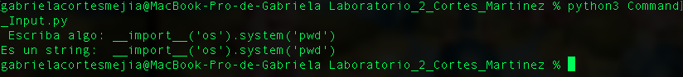

As discussed in class the payload won’t work for some reason.

7. What is the word number 9,732 in the rockyou.txt dictionary from github?

* **wwe123**

8. What is the maximum number of TCP ports allowed?

* El número máximo de conexiones TCP es **65535**. Estas conexiones se pueden conectar a diferentes IP de servidor.

9. What is an abuse case? (Be brief)

* A way to use a feature that was not expected by the implementer, allowing an attacker to influence the feature or outcome of use of the feature based on the attacker action (or input).

10. Making use of RegEx in python build a function that prevents XSS and SQLi.

